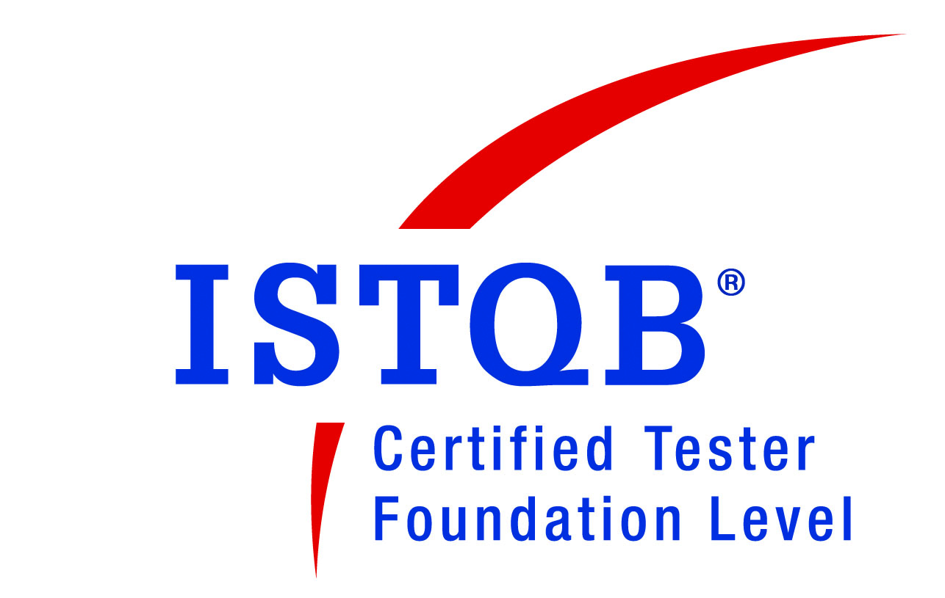
VENANTIUS BRITTO S.A
E-mail : vbrittosa2006@yahoo.com
Contact No : 9980375798
Date of Birth : 07.03.1987
Address : No. 10/4, Berlie Street Cross,
Langford Town, Shanthinagar,
Bangalore – 560 025.

OBJECTIVE
Aspire to achieve the best standards in the field of software testing in the corporate sector through a continuous process of learning, innovation, integrity, determination and hard work with a view to contribute to the success of the organization.
PROFESSIONAL SUMMARY
- “ISTQB certified Tester” – Foundation Level.
- Working as System and Development Tester with WPA World Class Services (I) Pvt Ltd (ISO 27001 – certified company)., Bangalore.
- Overall Experience of 7 years with WPA World Class Services (I) Pvt Ltd., Bangalore
- 3 years of experience in Manual Testing in Insurance Domain
- Selected and undergone New Process and Application Testing Trainings at Parent Company – Taunton, UK.
- Experienced with Bug Tracking tool – JIRA and Task Vision
- Extensively worked on Manual Testing under Agile.
- Well Experience in Black Box Testing.
- Profound experience of Automated testing tool - QTP
- Clear understanding of Software Development Life Cycle and Test Methodologies.
- Experience in Design, development and executing Test Cases.
- Extensive experience in preparing Test Cases and Test Reports.
- Experience in Functional Testing, Integration Testing and UI testing.
- Experience in Manual Testing to validate the Functionality of the product.
- Representation of Test team (WCS Dept.) in Project meetings.
- Communication and reporting to Developers, White box testers and other departments in Parent Company, UK.
- Team player with Good communication and Inter personal skills.

EDUCATIONAL QUALIFICATION
- MBA in MADURAI KAMARAJ UNIVERSITY affiliated to MADURAI University (2011)
- B.com in St. JOSEPH'S EVENING DEGREE COLLEGE-Autonomous (2008)
- PUC in St. JOSEPH'S PU EVENING COLLEGE (2005)
- SSLC in St. PATRICK’S BOYS HIGH SCHOOL (2003)
PROFESSIONAL EXPERIENCE
- Working in WPA World Class Services (India) Pvt Ltd (ISO 27001) as Systems Support Tester till date (6+ years).
- Worked in Xplore Infosystems as Team Lead for 2.4 years.
PROJECT SUMMARY
Projects Profile:

Client : WPA, UK.
Project Title : iNaxos and Naxos Modules.
No. of Modules : 20 modules (includes Processing, Quality Checking and Report Generation
roles/modules)
Testing approach: Manual
Methodology : Agile (Kanban)
Tools used : Jira (Kanban system), Versionone and TaskVision.
Project #1 : iNaxos – Indexing

Description : iIndexing module is used to match a document to a customer record
searched from database server and index/move it to the appropriate work flow
based on the document type.

Project #2 : iNaxos – Buy

Description : iBuy is used to add Individual and Group records on to our database as per the
policy request and checking of validation and duplication of records

Project #3 : iNaxos – Quotes

Description : Providing Quotation for Corporates Clients as per their request on
product/options. It includes Creation of Quote headers, declining of quotes,
requesting for further information, uploading of quote spread
sheet on to the quote engine, pricing of quotes, and generation of quotes.

Project #4 : iNaxos – PAN

Description : Payment adjustment note role is used for recouping or reversal and repayment of claims paid. It includes modifications of benefits and data’s on incorrect claim
payments and re-issue accordingly.

Project #5 : iNaxos – Claims

Description : Claim is role which keeps a track of medical information of
Customers. Based on the conditions provided validation and
verification is done on the claim headers. This information is passed on to the
underwriting department for further claim process

Project #6 : iNaxos – Provider Admin

Description : This role includes addition of specialists and therapists on to database and
amendments to existing provider’s record and also validation of information
(like Name, address, speciality, bank details etc.)

Project #7 : iNaxos – Invoices

Description : iInvoice role involves in claim payments and dealing with reminders/duplicates

Responsibilities on above Projects:
- Designing Test cases after analysing the specifications Documents.
- Performed the functional, Integration, UI testing.
- Reporting the defects and validating it.
- Performed regression testing to validate the resolved defects on every build.
- Updating of test cases based on the implementation changes.
- Understanding the User requirements and tracking the requirement changes in the test cases to make sure that each of the requirements gets mapped to a test case.
- Submiting a clearly written bug reports and assigning them to developers for fixes.
- Involved in weekly status reporting and official meetings.

TECHNICAL SKILLS
Course : Diploma in Software Testing
Skills : VB Scripting, SQL and knowledge in Quality Centre
Automation tool : Knowledge on QTP 10.0
Test Management tools : Jira – Kanban System, VersionOne and TaskVision.
Others : Knowledge in MS office and Adobe Photoshop.

ACHIEVEMENTS
- Awarded several times for monthly Best Performance.
- Awarded for achieving the Best Quality in Advance Level (2010).
- Awarded Chairman Shield in Annual General Meeting 2010.
- Organized Social outings & created awareness about the social responsibility.
- Organized team activities & trips.
- Member of ‘Vision & Values’ committee in the Company.
- Performed Internal Audit duties and responsibilities relating to ISO – Information Security Incident Management, Business Continuity, Human Resource Security, Access Control, Physical Security, Compliance (third party contracts).
- Conducted team meetings & generated team reports as a Deputy Team Lead.

KEY STRENGTHS
- Urge to take new responsibilities and pursue them.
- Excellent presentation, communication and writing skills.
- Receptive to learning new processes/skills and adapt to new environments quickly.
- Positive thinking.
- Ability to handle multiple tasks and work collaboratively regardless of team.
- Confident of dealing with a range of people across different regions.
- Team facilitator, sincere and self-confident.

DECLARATION
I hereby declare that all the information furnished above is true to the best of my knowledge
and I take complete responsibility for any false information.

PLACE: BANGALORE

DATE: Yours Faithfully,

(S.A. VENANTIUS BRITTO)

